1. Host IP: 192.168.1.101 Destination Host IP: 143.89.14.34

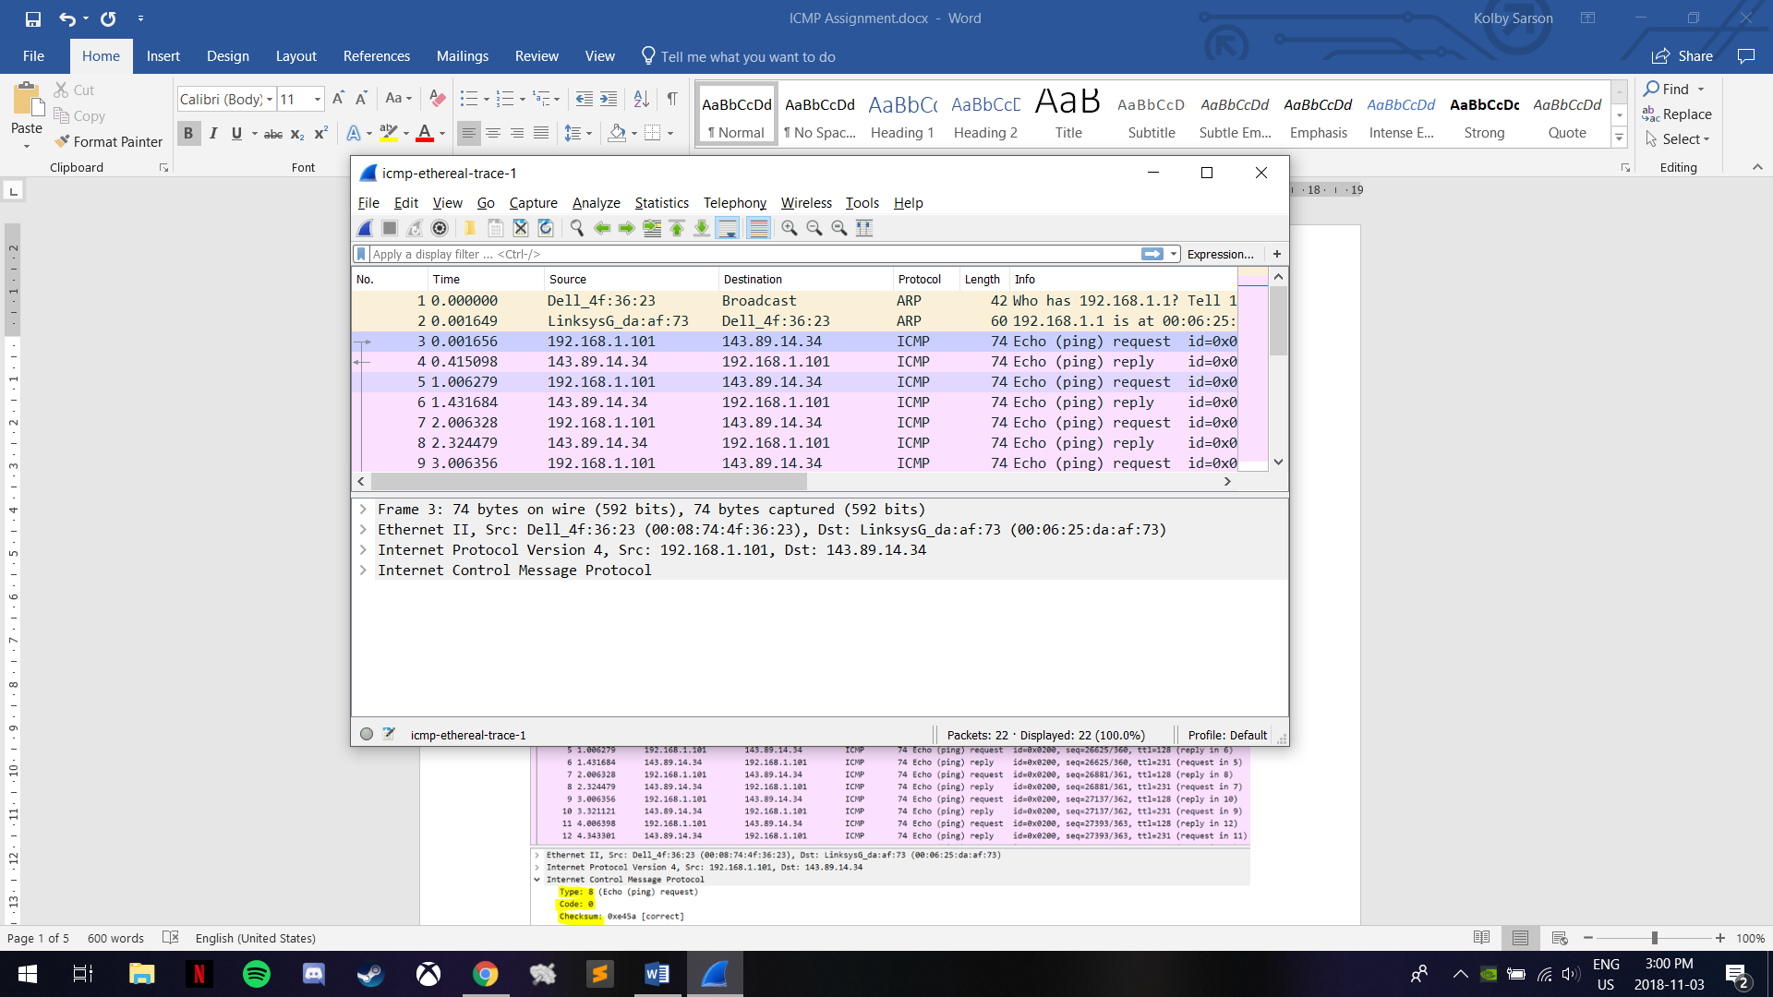

1. An ICMP does not have source and destination ports since communication is done between hosts and routers within the network layer.
2. The ICMP Type is 8 (Echo (ping) request) and the Code is 0. The other fields are Checksum, Identifier (BE), Identifier (LE), Sequence number (BE), Sequence number (LE), and Data.

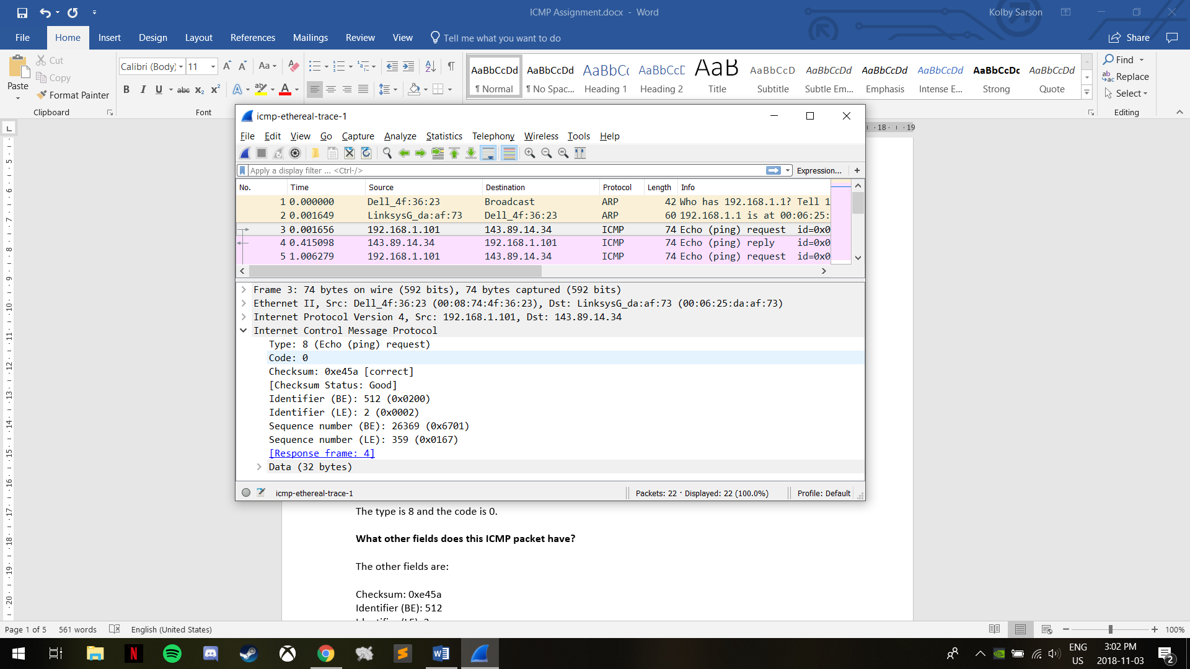

The Checksum, Sequence Numbers, and Identifier Fields are 2 bytes each.

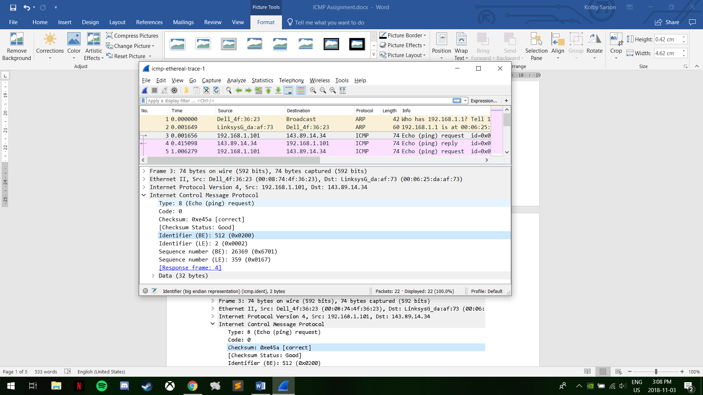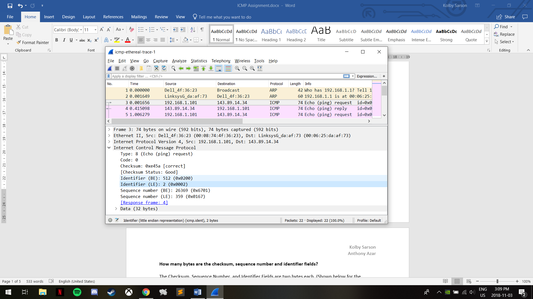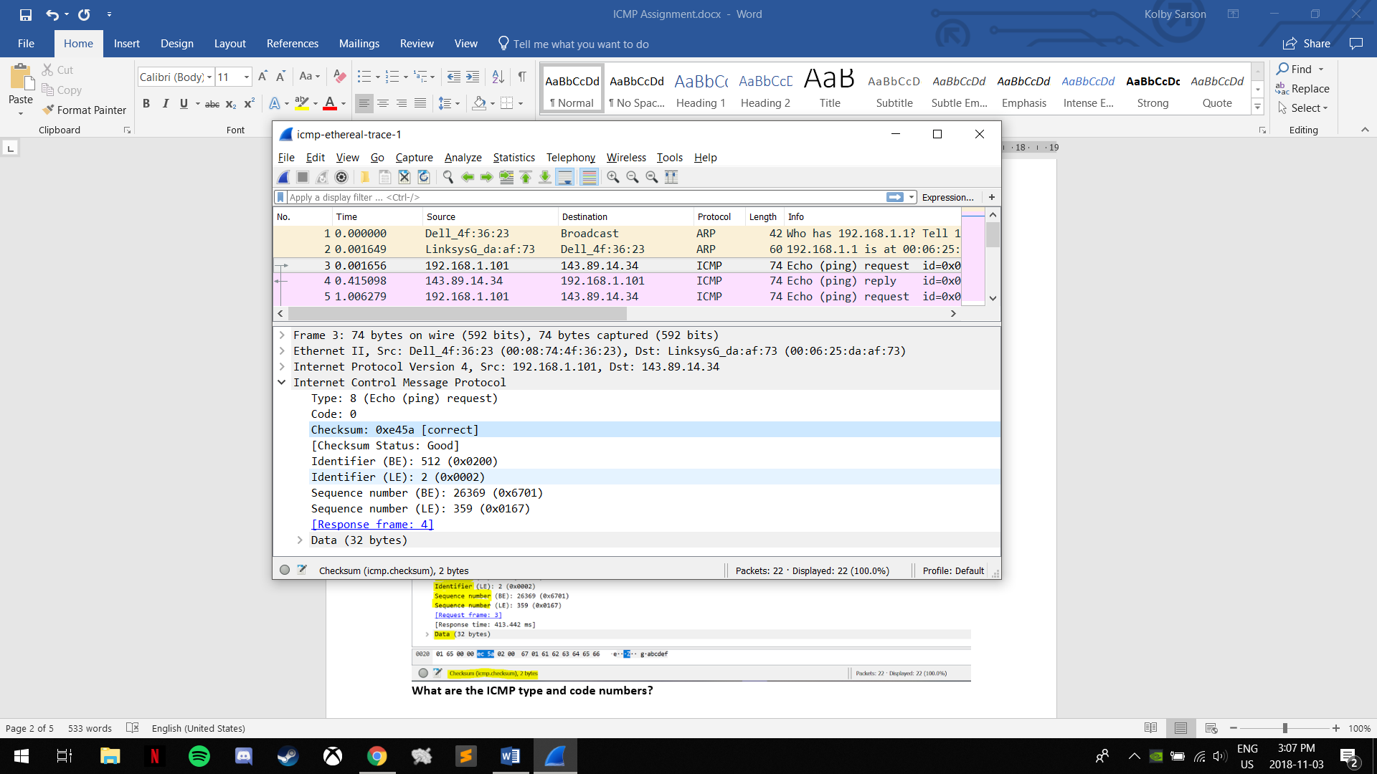

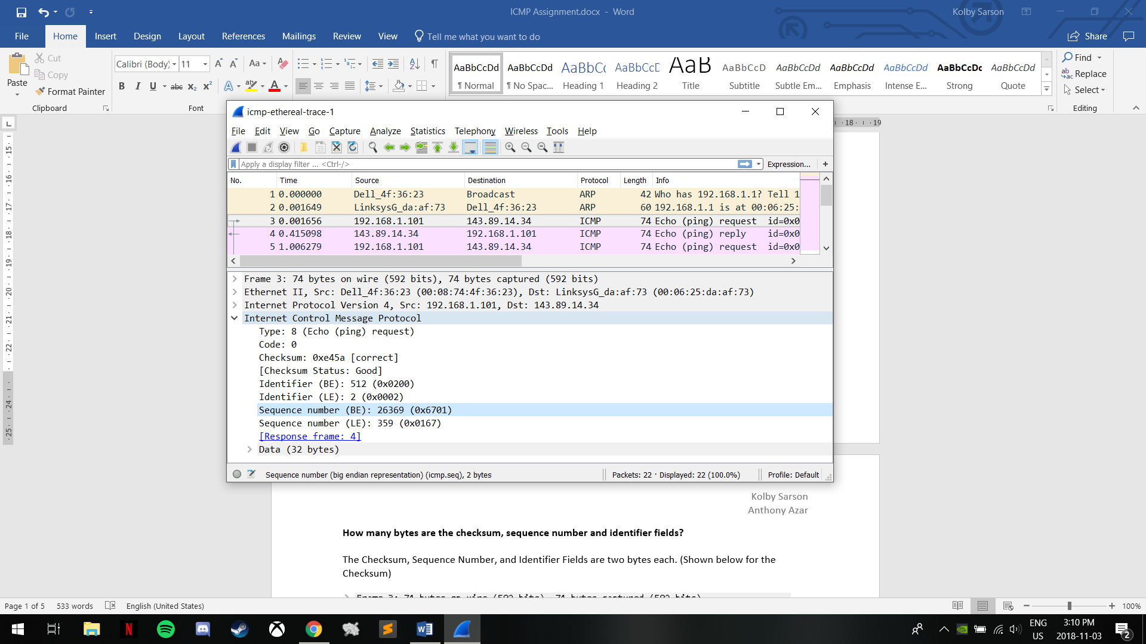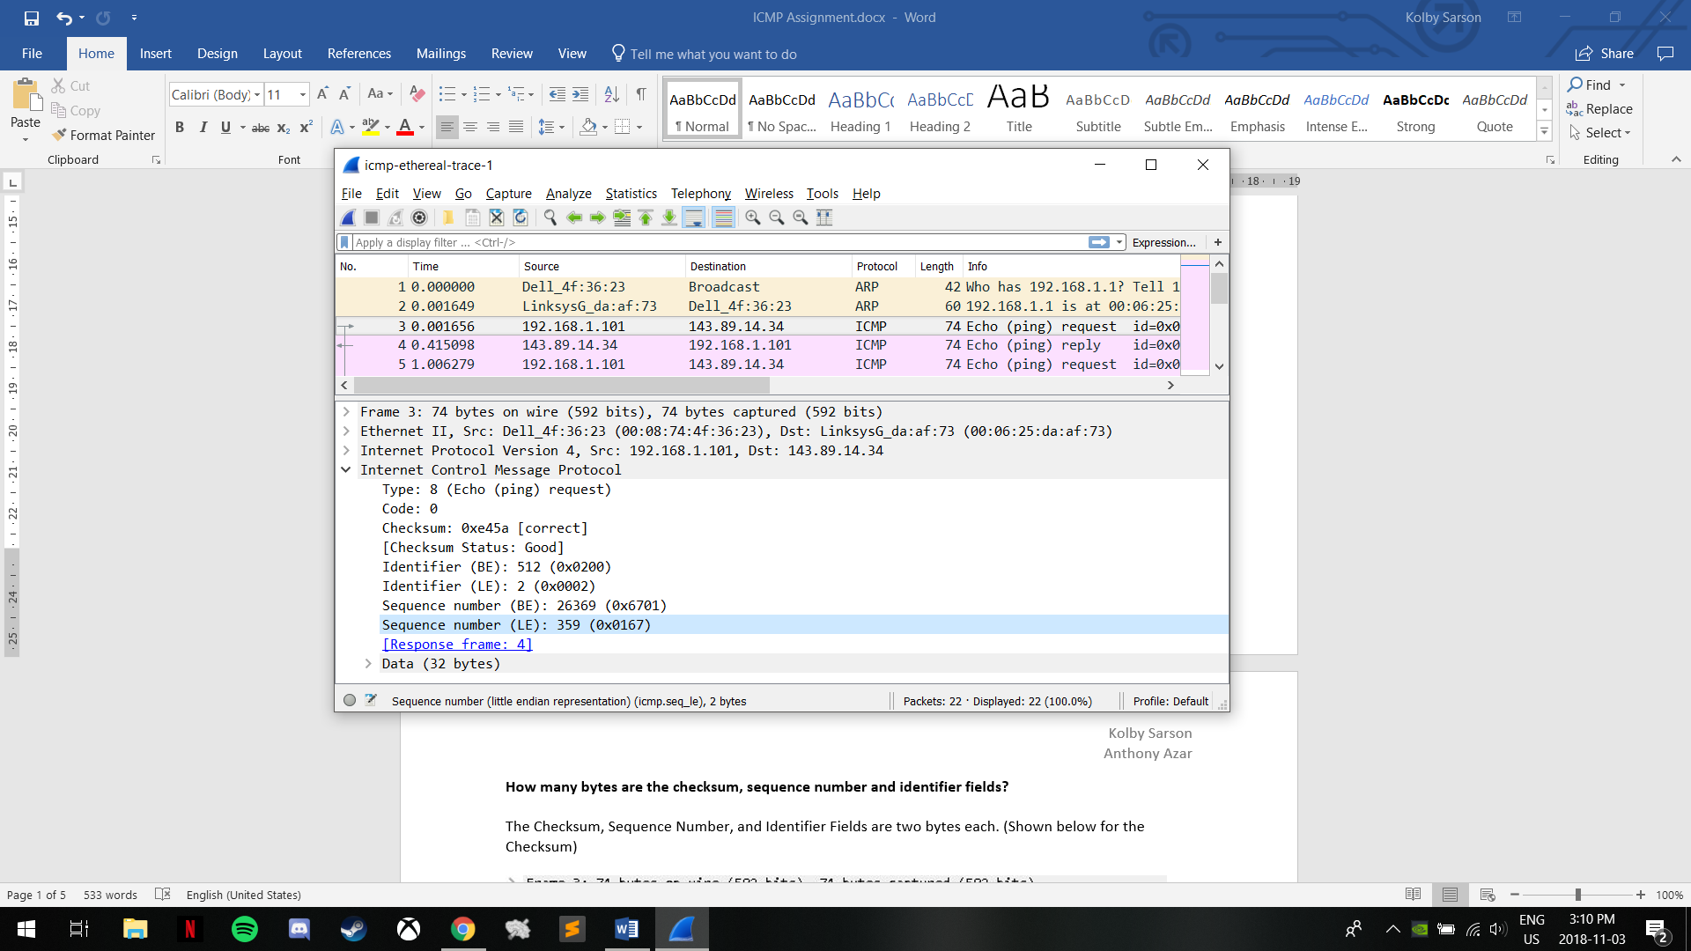

1. The ICMP Type is 0 (Echo (ping) reply) and the Code is 0. The other fields are Checksum, Identifier (BE), Identifier (LE), Sequence number (BE), Sequence number (LE), and Data.

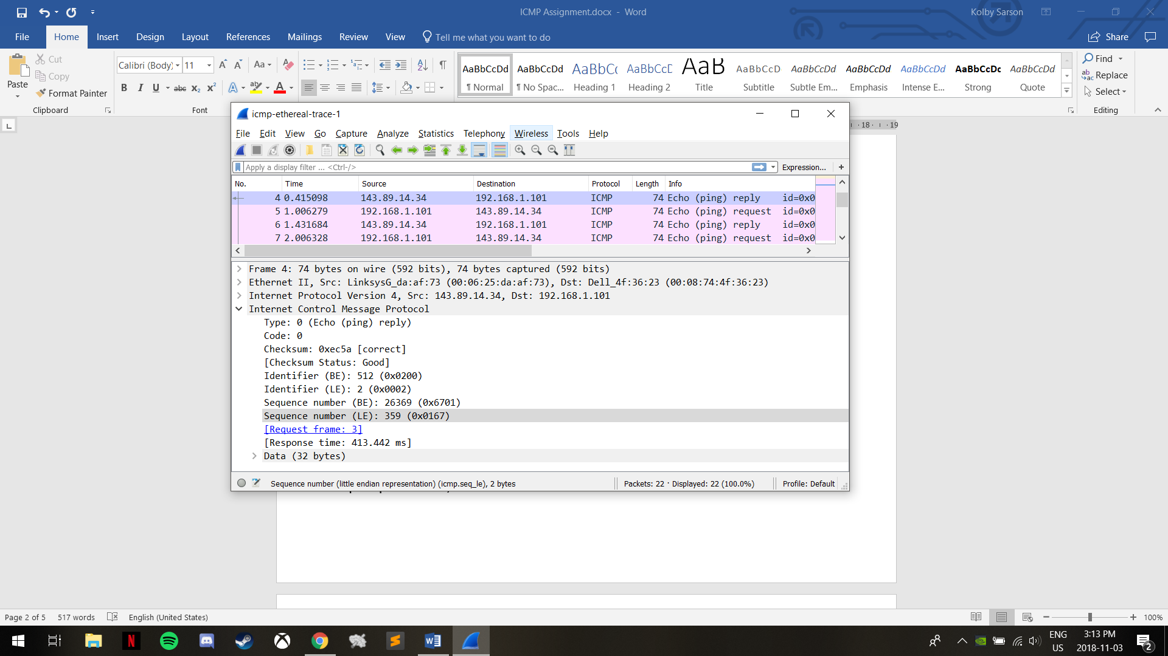

The Checksum, Sequence Numbers, and Identifier Fields are 2 bytes each.





1. Host IP: 192.168.1.101 Destination Host IP: 138.96.146.2

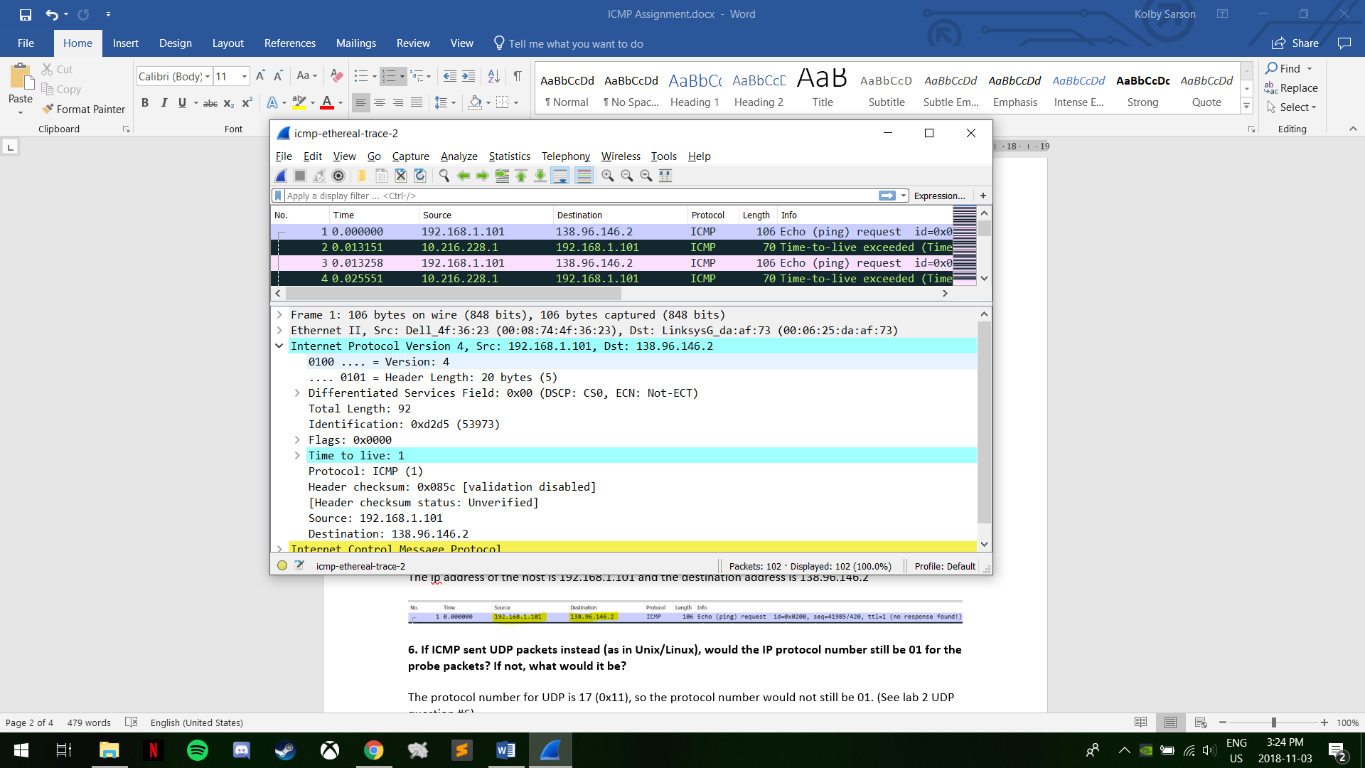

1. The UDP protocol is 17 (0x11), so the protocol number for the probe packets would not be 01 (Which we saw in our UDP lab in question 6).
2. The Checksum, Sequence numbers, and Data are different between the two Echo (ping) requests. Additionally, there was no response in this part, but there was a response in the first part (Comparisons made with question 3 screenshot).

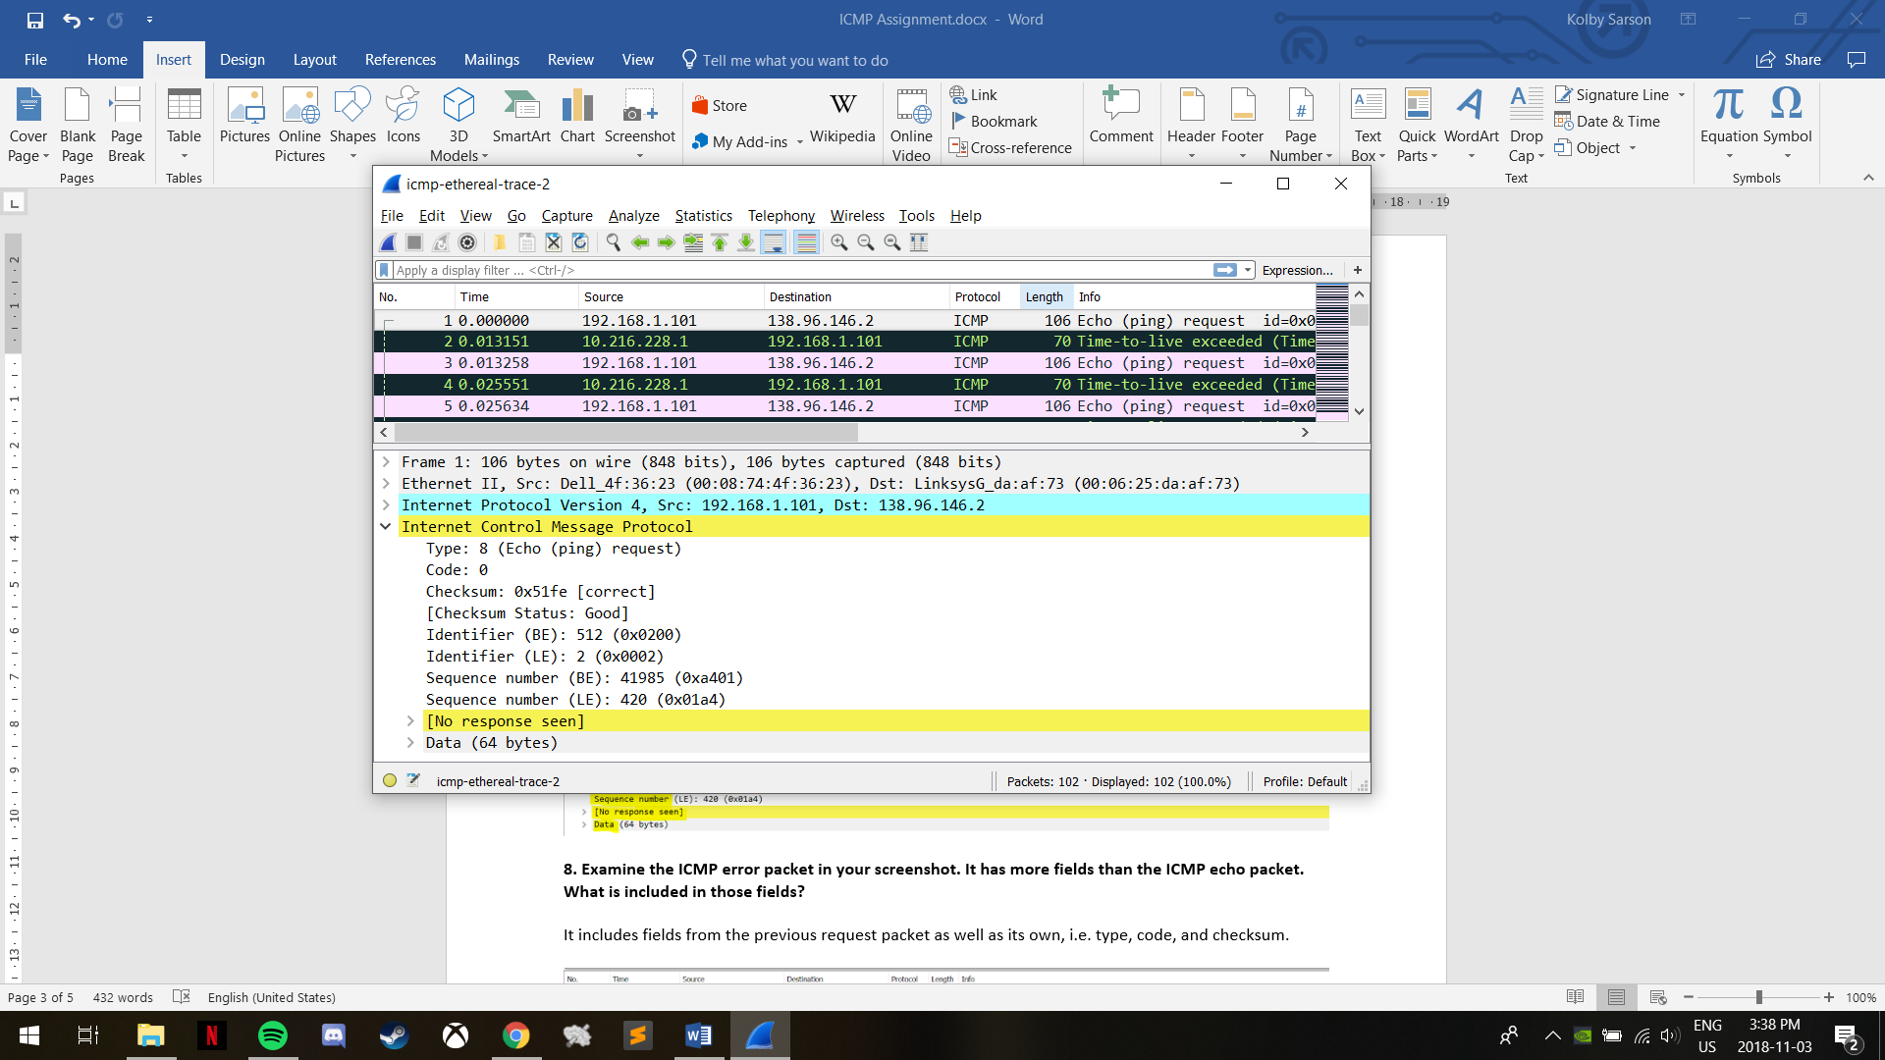

1. The error packet includes fields from the previous request packet (belonging to that request packet) as well as its own Type, Code, and Checksum field (individual to the error packet).

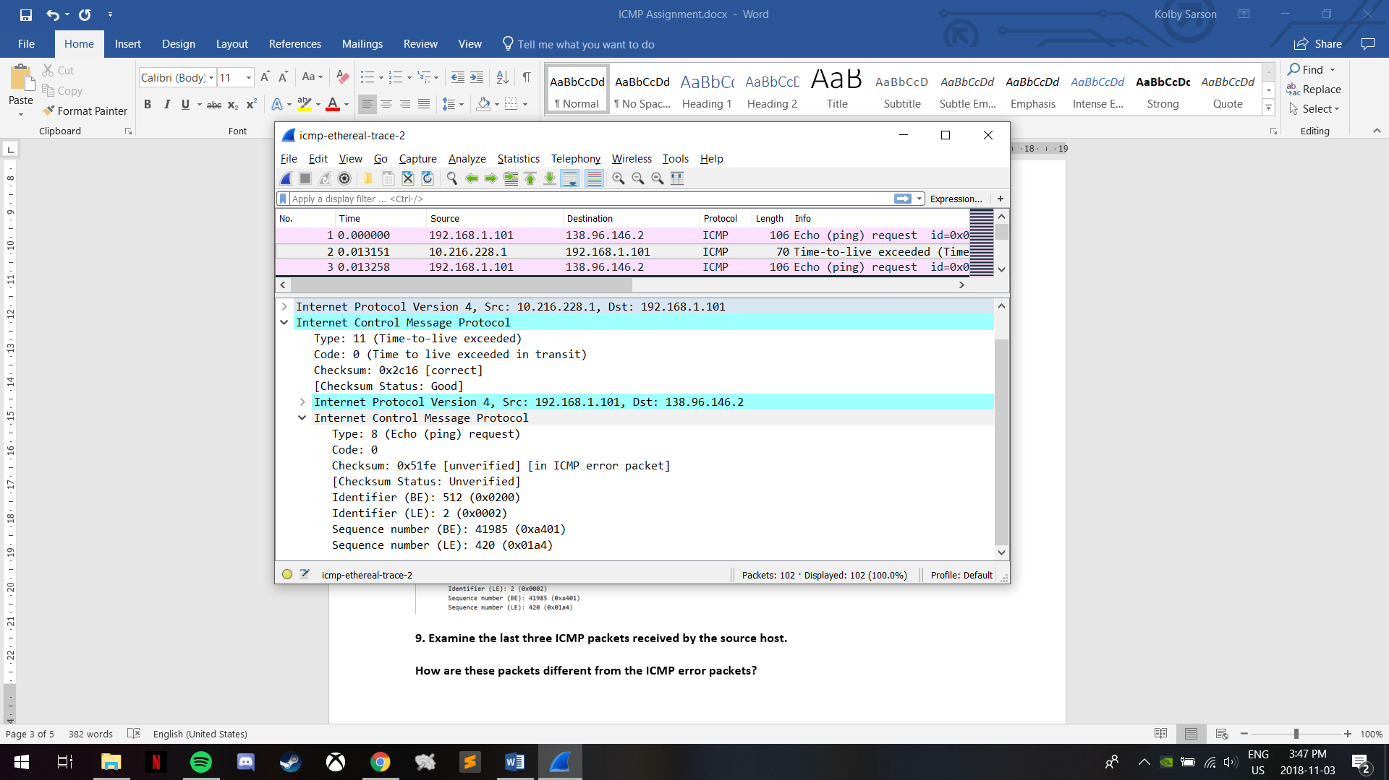

1. These packets are different because they are of Type 0, indicating a reply, rather than Type 11, which would indicate TTL-exceeded. They are different because they reached their destination prior to the TTL being exceeded.

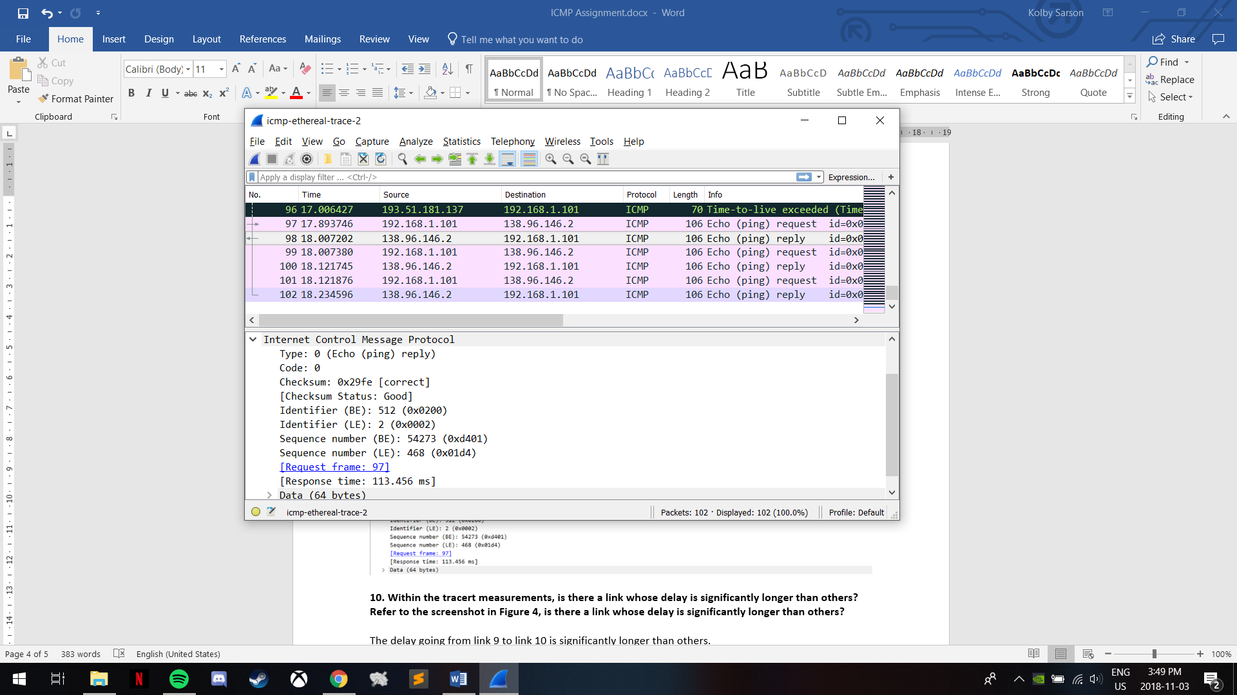

1. Yes, there is a link with a delay significantly longer than the rest. The delay that is significantly longer than the others is from 9 to 10. Link 9 is in New York, USA (**nyc**.opentransit.net) and link 10 is in Pastourelle, France (**Pastourelle**.opentransit.net and the **.fr** extension).